Project Report – Augmented Reality Card Scanner

Project Title: Augmented Reality Card Scanner
Developed by: Anmol Shrivastava
Course: Btech CSE 3rd Year
Enrolment No- E23CSEU0068
Abstract
This project demonstrates the use of Augmented Reality (AR) for enhancing traditional visiting cards using Unity 2022 LTS and Vuforia Engine. A college ID card was used as a marker, which when scanned through the mobile app, displays interactive elements such as LinkedIn, Codilio profile, and project links, along with a 3D avatar. The project focuses on marker-based AR, interactive clickable links, and ethical design principles.

Objectives
- To learn the fundamentals of AR development using Unity and Vuforia.
- To integrate 3D avatars, clickable links, and UI interactivity in AR.
- To explore practical applications of AR for networking and professional branding.
- To ensure accessibility and privacy-friendly implementation.

Tools and Technologies
- Unity 2022 LTS (development engine).
- Vuforia Engine (for marker database and AR camera).
- Ready Player Me SDK (for generating 3D avatar).
- C# scripting (for animations and clickable links).
- Android/iOS (deployment target).

System Design & Implementation
Step 1: Marker Setup
- Used college ID card as the marker.
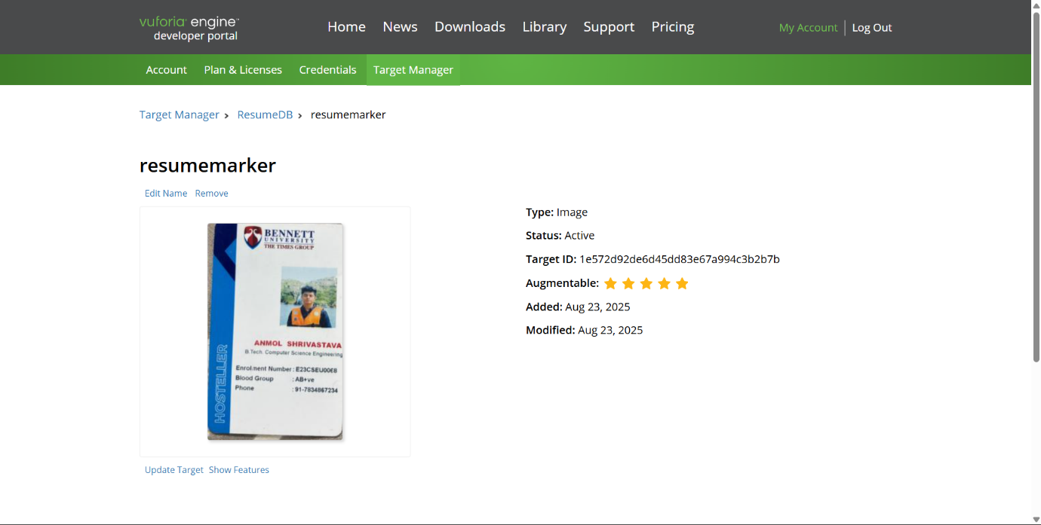

- Added the ID card image into Vuforia database as an image target.
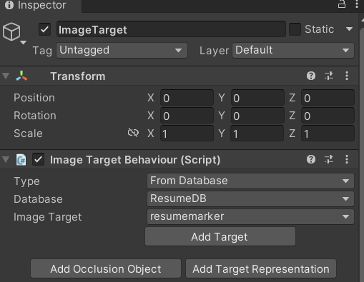

- Replaced Unity’s Main Camera with Vuforia AR Camera for scanning.
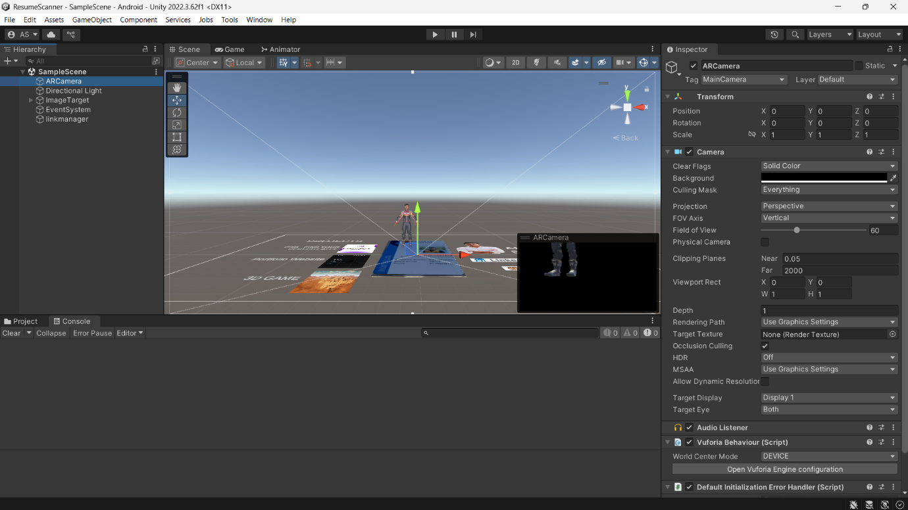

Step 2: Augmented Elements Placement
- Added LinkedIn, Codilio profile, and project links as clickable 3D UI buttons.
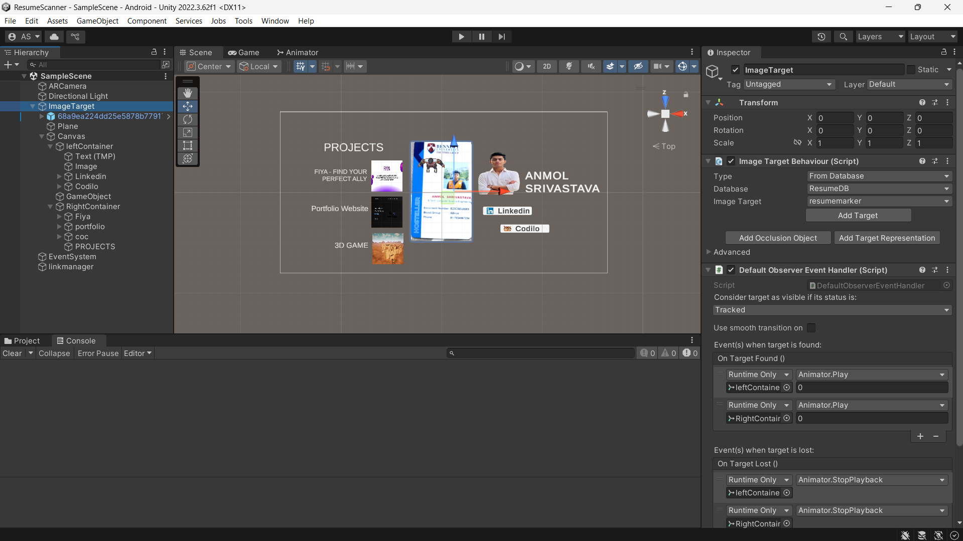

- Positioned the buttons to appear around the scanned card with fade-in animations.
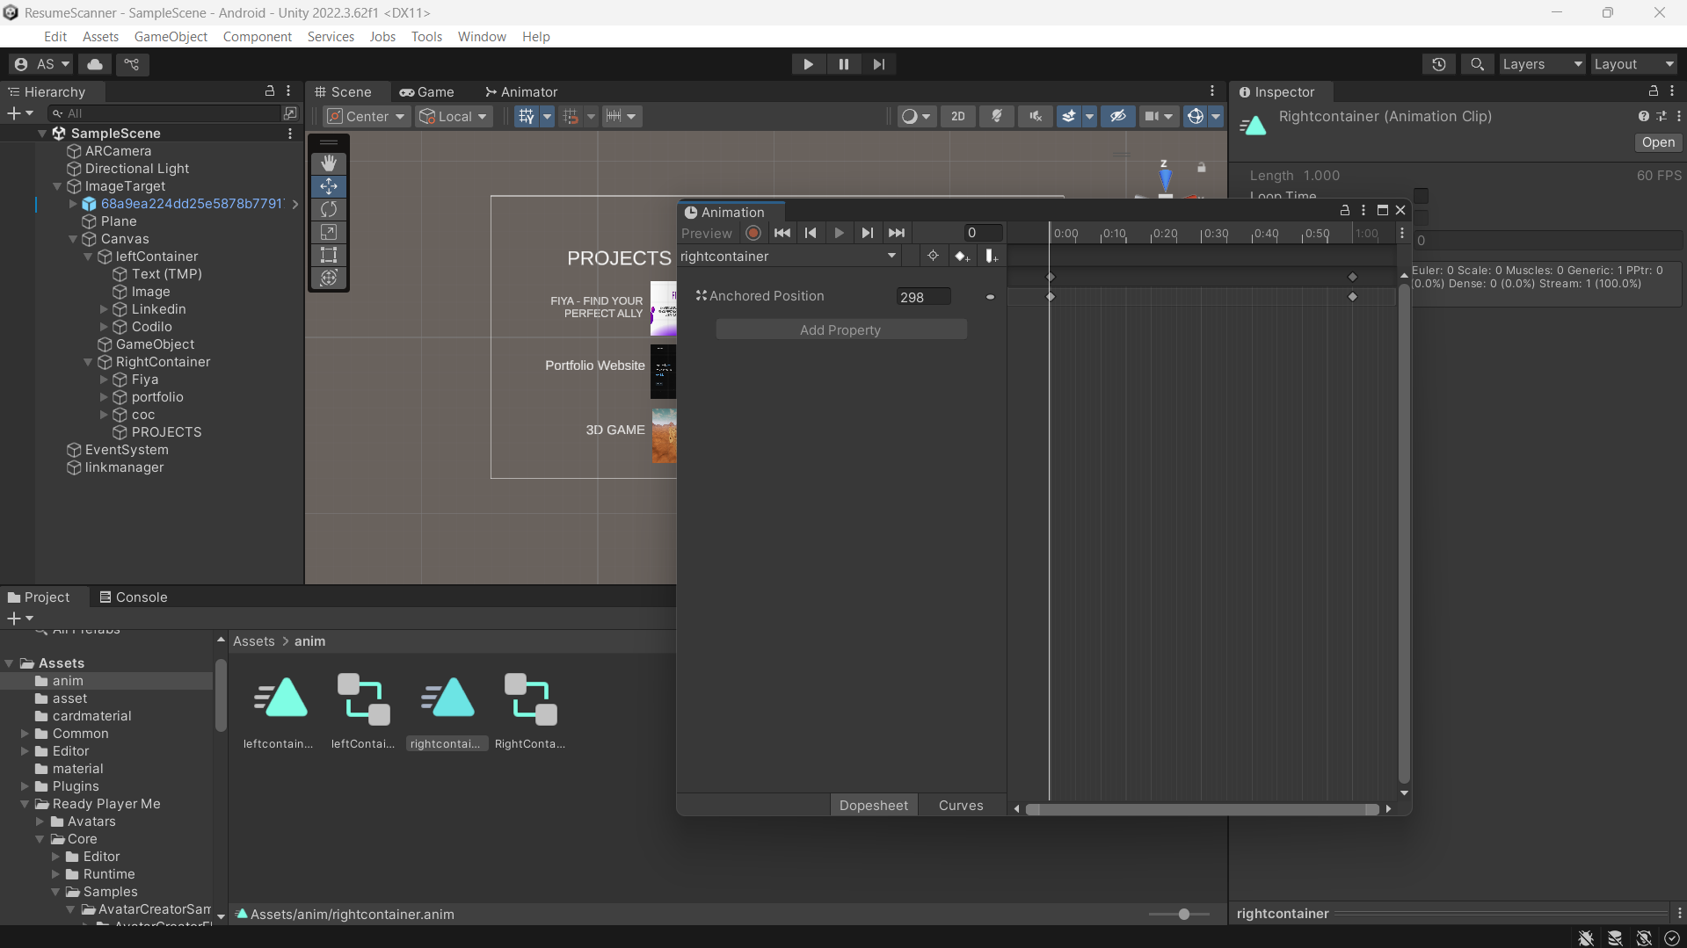

- Made objects clickable using C# script that opens links in a browser.
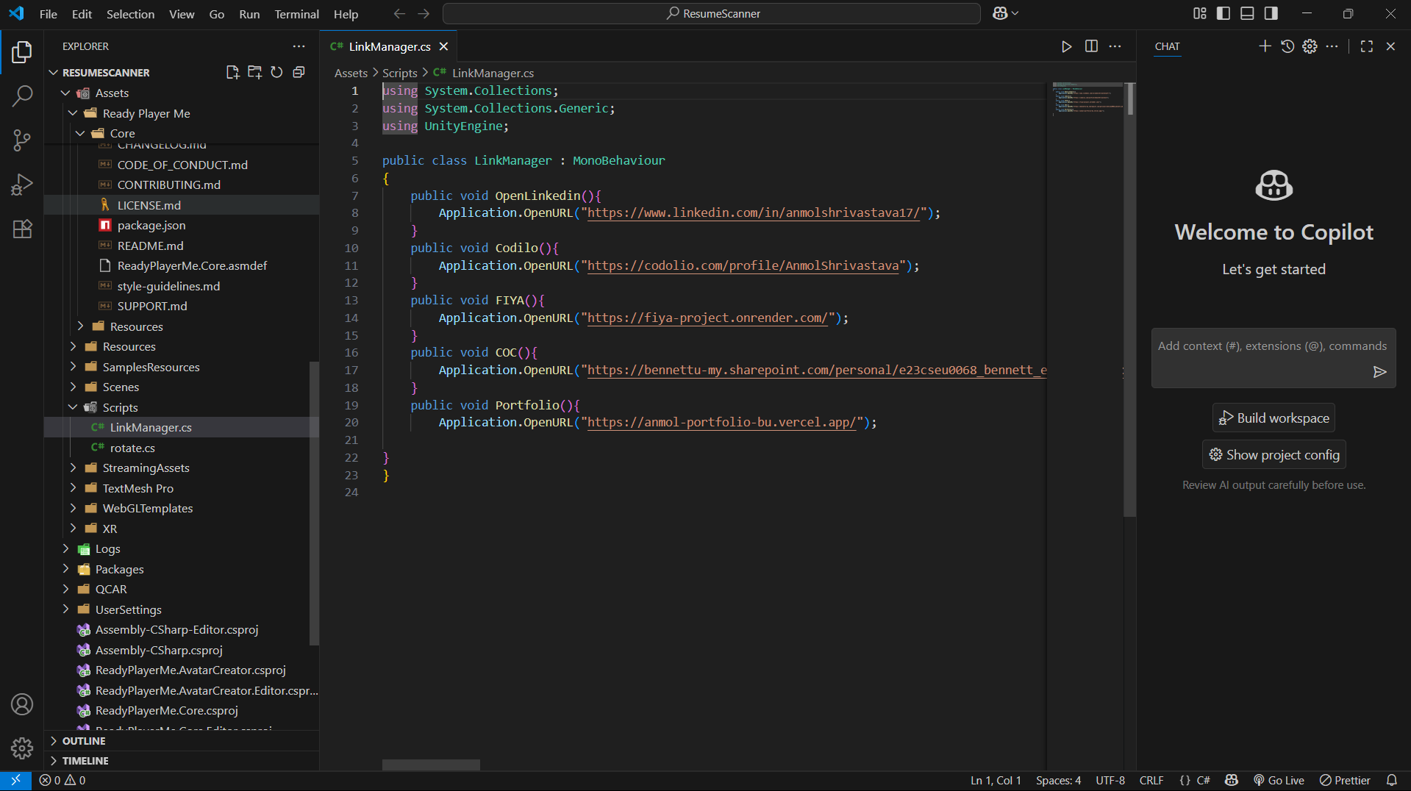

Step 3: Avatar Integration
- Used Ready Player Me SDK to generate a 3D avatar.
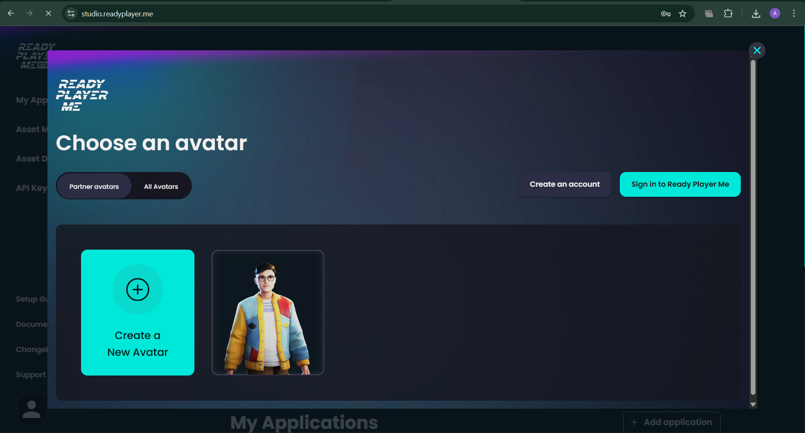

- Placed the avatar directly on top of the marker when scanned.
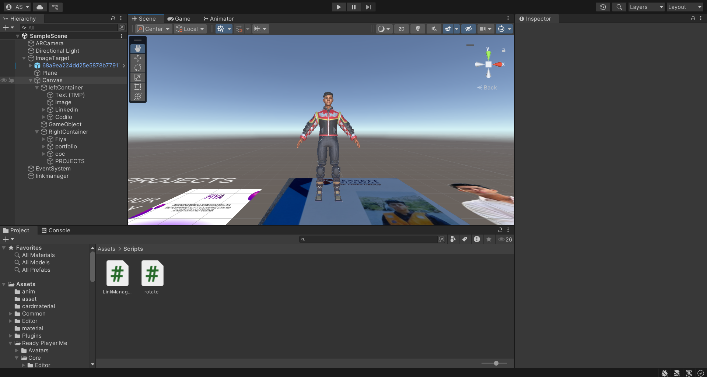

Step 4: User Interface Setup
- Designed scanning UI using Unity’s built-in UI elements.
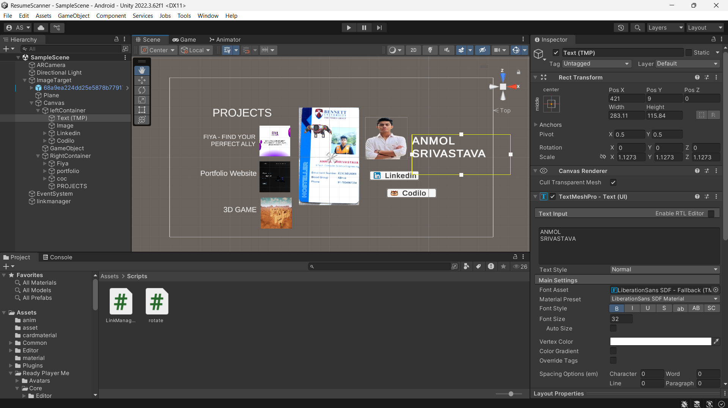

- Added buttons and 3D planes to improve interactivity and visuals.
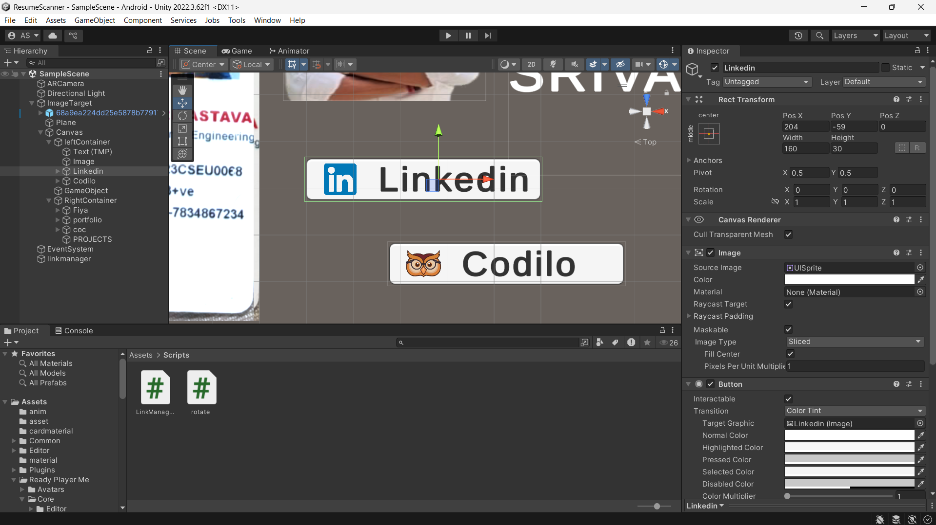

Step 5: Interactivity Implementation
- Used OnClick () functions in C# to open external links (LinkedIn, Codilio, Projects).
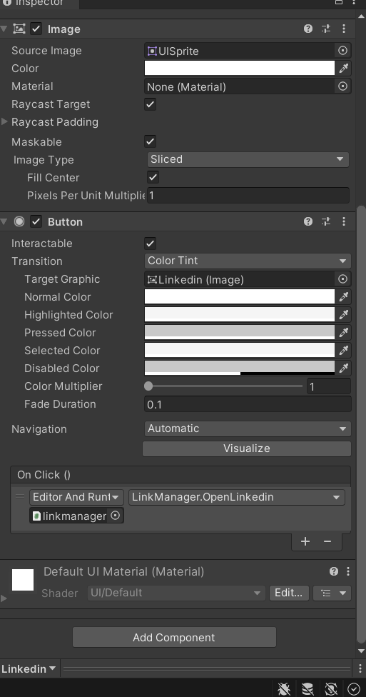

- Optimized animations for smoother AR experience.
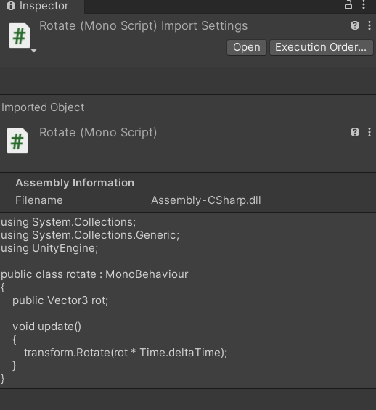

Challenges and Solutions
- Material Issue
  - Problem: In the latest Unity version, materials couldn’t be applied to the ID card marker.
  - Solution: Switched to Unity 2022 LTS, which fixed the issue.
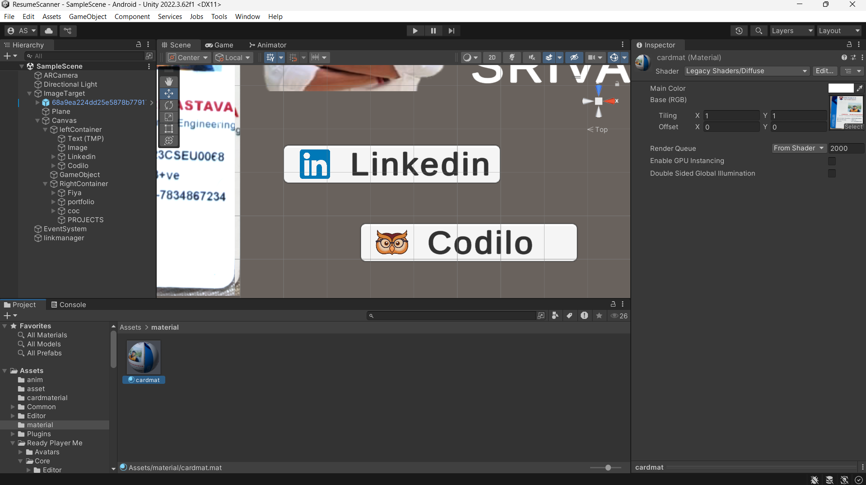
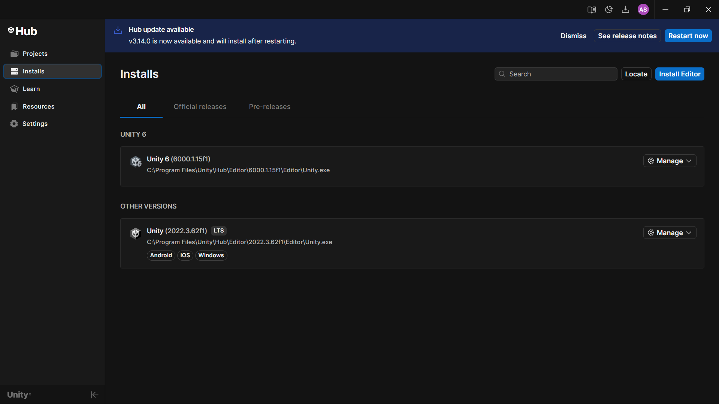

- Build Error (Wrong Scene)
  - Problem: The build was loading a recommended scene instead of the main AR scene, causing a blank output.
  - Solution: Corrected the build settings to include the main AR scene as the startup scene.
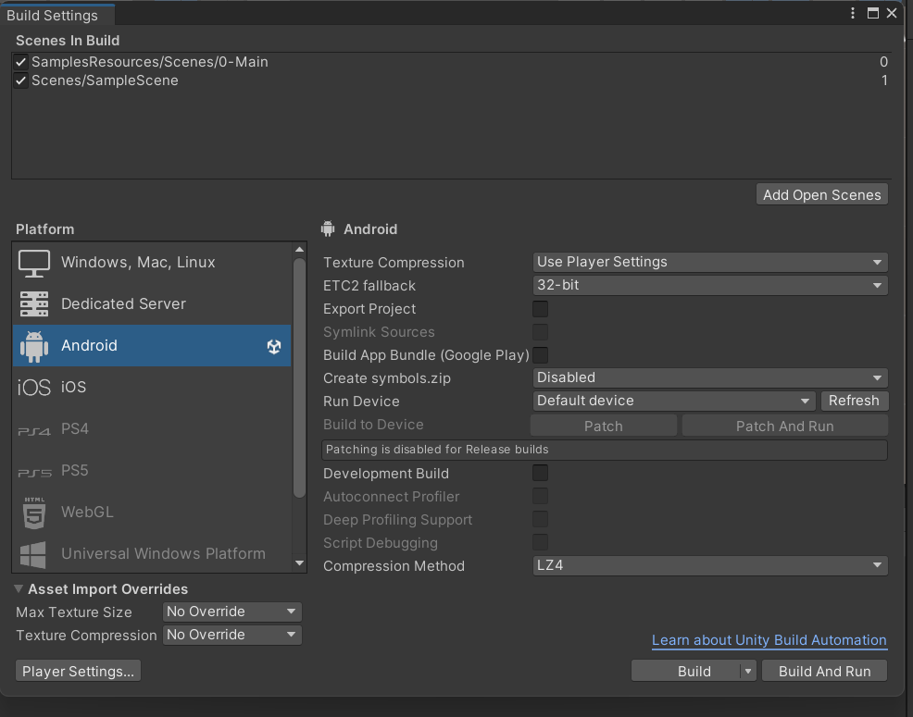

Results & Discussion
- Successfully scanned college ID card as a marker.
- Displayed clickable links (LinkedIn, Codilio, Projects).
- Avatar integration with animations enhanced engagement.
- System works smoothly on mid-range devices.

Conclusion & Future Scope
This project showcased the potential of AR in personal branding by turning a physical ID card into an interactive digital profile. Future improvements can include:
- Adding voice command support.
- Expanding to AR Cloud Anchors for marker less tracking.
- Integrating AI-based smart recognition for auto-detecting cards.

Appendix
- GitHub Link: [Insert link]
- Demo Video Link: [Insert link]

